
CHENNAI PUBLIC SCHOOL

INDIAN WEATHER INTELLIGENCE & ANALYTICS SYSTEM - IWIAS

INVESTIGATORY PROJECT
Computer Science
2026-27

Student Name:Anish Ganesh
Class & Section: XII - B
Roll No.: 18


CERTIFICATE

This is to certify that, Anish Ganesh student of Class XII B, Chennai Public School, Anna Nagar, has completed project titled Indian Weather Intelligence & Analytics System - IWIAS during the academic year 2026-27 towards partial fulfillment of credit for the SSCE Practical Evaluation, under my supervision.

_______________ _______________
Mrs. Harsha Varun External Examiner
(Computer Science Teacher)

_______________________
Mrs. Sukanya Ravi
(Principal) School Seal

ACKNOWLEDGEMENT

I consider it a privilege and honour to express my heartfelt gratitude to all those who have supported and guided me in the successful completion of this project.

I sincerely thank Mrs. Sukanya Ravi, Principal, for her encouragement, support, and facilities that made this project possible. I express my deepest gratitude to Mrs. Harsha Vinod, my Computer Science Teacher, for her valuable guidance, constructive suggestions, and constant encouragement. Her insightful observations and helpful feedback greatly assisted me in developing my ideas and completing this project successfully. I am also grateful to Mrs. Jayalakshmi, Computer Lab Assistant, for her continuous assistance, cooperation, and guidance during the practical work.

Finally, I would like to express my heartfelt gratitude to my parents for their unconditional support, encouragement, patience, and motivation throughout the project. Their constant belief in me inspired me to work with dedication and perseverance.

I am truly thankful to everyone who contributed, directly or indirectly, to the successful completion of this project.

INTRODUCTION

The Indian Weather Intelligence and Analytics System (IWIAS) is a Python-based weather monitoring and analytics application developed to collect, store, analyze, and present weather information for cities across India. The system integrates Python programming, weather APIs, MySQL database management, data analysis, and graphical visualization to provide a centralized platform for studying weather conditions.
IWIAS allows users to search for Indian cities and retrieve important weather parameters such as temperature, humidity, atmospheric pressure, wind speed, and weather conditions. The collected information can be stored in a MySQL database along with the city name and time of observation, creating a historical record that can be used for further analysis.
The system provides facilities for parameter-to-parameter weather analysis, historical data analysis, graphical visualization, weather forecasting, weather alerts, and automated weekly report generation. By storing weather observations in a structured MySQL database, IWIAS enables users to study relationships between different weather parameters, observe variations over time, and identify significant weather patterns.
The project also incorporates a weather forecasting module to provide predicted weather conditions for upcoming periods. The collected weather data is processed and utilized for analysis, forecasting, alert generation, and weekly reports, making IWIAS a comprehensive platform for monitoring, analyzing, and understanding weather conditions.
The primary objective of IWIAS is to develop a unified weather intelligence system that collects and analyzes real-time and historical weather data, studies relationships between weather parameters, provides forecasts and alerts, and generates automated weekly reports for effective weather monitoring.



IWIAS

CASE STUDY

Weather is an important part of everyday life and can influence agriculture, transportation, travel, education, public activities, and many other areas. India has a wide range of geographical and climatic conditions, resulting in significant differences in weather between cities and regions. A city such as Chennai may experience very different temperature, humidity, rainfall, and wind conditions from cities such as Delhi, Mumbai, Bengaluru, or Kolkata. These conditions can also change continuously throughout the day and across different seasons.
Monitoring such changes requires weather information to be collected and organized in a systematic manner. A person who wants to study the weather of several Indian cities may need to gather information from different sources and manually record the values. Maintaining such records over several days or weeks can become difficult, especially when large amounts of information such as temperature, humidity, atmospheric pressure, wind speed, and rainfall have to be compared.
The Indian Weather Intelligence and Analytics System (IWIAS) is a software project designed to address this problem by providing a centralized system for managing weather information from different Indian cities. The system uses a weather API to obtain current weather data and processes the information using Python. The collected data can then be stored in a MySQL database, creating an organized historical record that can be accessed whenever required.
The system allows users to search for cities and examine their weather conditions through a graphical interface. Weather records from different cities can be compared to identify differences in temperature, humidity, wind conditions, and other parameters. Graphical representations can also be used to make changes and variations easier to understand. By retaining historical information, the system can help users observe how weather conditions change over time rather than viewing only the current conditions.
This project represents a practical example of how a database-driven application can be used to manage real-world environmental information. IWIAS combines Python programming, API integration, MySQL database management, data processing, and graphical visualization to create an organized platform for collecting and analysing weather data. The project is intended to demonstrate how technology can transform continuously changing weather information into structured and useful data for comparison and study.

OPERATING INSTRUCTIONS

On running the Python program, the user will be directed to the Indian Weather Intelligence and Analytics System (IWIAS) graphical user interface developed using Tkinter. The main window provides buttons for accessing the different weather monitoring and analysis functions.
The main interface provides the following options:
- Get Weather
- Search History
- Correlation
- Trends
- Forecast
- Alerts
- Reports
- Exit
Button Functions
- Get Weather – Retrieves and displays the current weather conditions of the entered city, including temperature, humidity, pressure, wind speed, and weather condition.
- Search History – Displays the recently searched cities stored in the MySQL database.
- Correlation – Generates a graph to analyze the relationship between two selected weather parameters for a particular city.
- Trends – Generates a graph showing how a selected weather parameter changes over time for a particular city.
- Forecast – Displays predicted weather conditions for upcoming periods.
- Alerts – Identifies and displays alerts when specified weather conditions meet the defined alert criteria.
- Reports – Allows the user to select an available weekly report and displays its file location so that the user can access it.
- Exit – Closes the IWIAS application.

On selecting any of the above options, the user will be able to perform the corresponding operation. The Tkinter-based interface is simple and user-friendly, allowing the user to navigate through the different functions using buttons and input fields.
When the program is executed, it connects to the weather_data MySQL database and retrieves or stores the required weather information. The user can search for weather conditions of a city, view recently searched cities, analyze relationships between different weather parameters, and study changes in weather conditions over time using graphical representations.
The system also provides weather forecasting and generates alerts. A weekly weather report will also be generated containing relevant weather information and analysis.
The automatic weather update module periodically retrieves weather data for Indian cities and stores the observations in the MySQL database. This stored data is then used for historical analysis, graphical visualization, forecasting, alerts, and weekly report generation.
Once all required operations have been completed, the user can select Exit to close the application.

SQL TABLES

This project includes 5 MySQL tables each having a specific purpose.

Table | Purpose
weather_data | Stores weather details of searched cities.
forecast | Stores weather forecast details.
alerts | Stores weather alerts and warnings.
search_history | Records name of cities searched by users.
historical_data | Stores past weather records
city_coords | Stores geological coordinates
weekly_report_files | Stores weekly weather report files details

Table structures:
- weather_data:
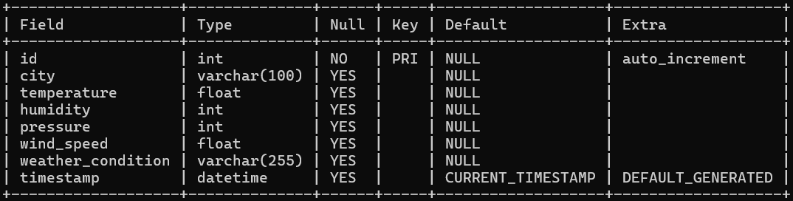

- search_history:
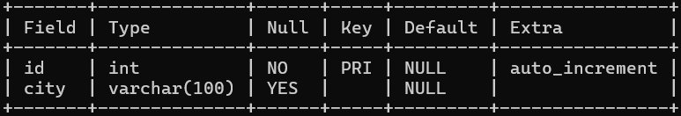

- forecast:
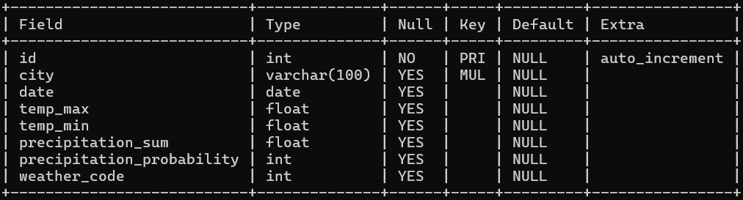
- city_coords: 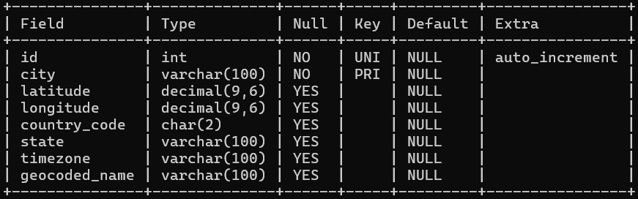

- alerts: 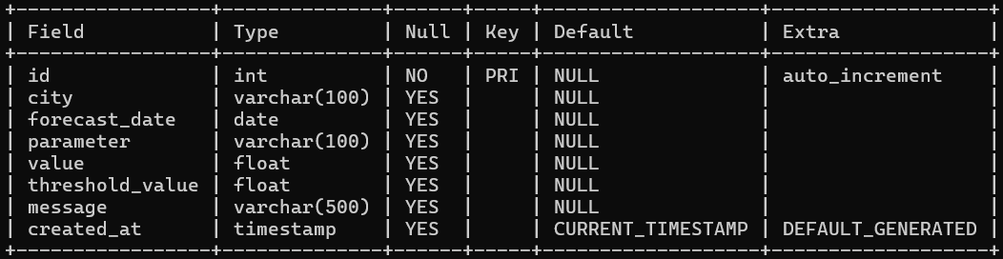
- historical_data: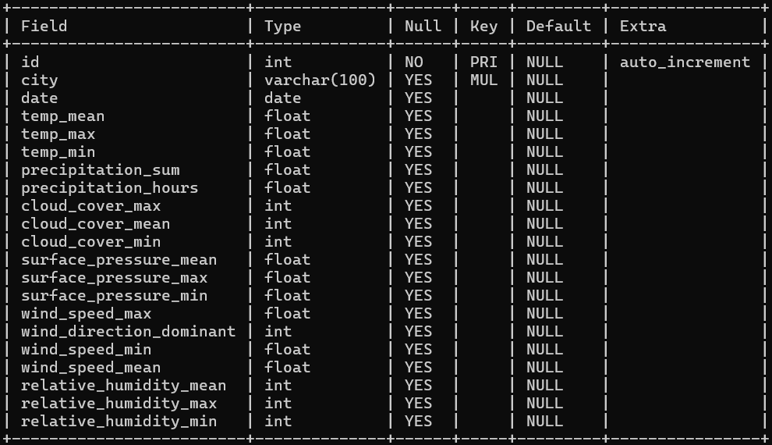

- weekly_report_files:
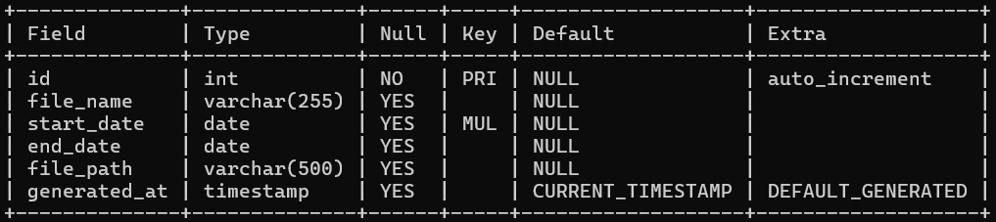

Source Code

The application follows a modular design consisting of five Python scripts. Of these, four modules handle asynchronous or scheduled data collection and database integration, while the fifth acts as the primary user interface for interaction and visualization.

Modules used | Purpose
tkinter | Used to create the graphical user interface (GUI)
datetime | Used for handling date and time-related operations.
requests | Used to send HTTP requests to APIs to retrieve geographical coordinates, historical weather data and forecast information.
mysql.connector | Used to connect Python programs to MySQL.
matplotlib | Used to create and display graphs.

- app.py
The app.py script is the main program of the IWIAS – Indian Weather Intelligence and Analytics System. It acts as the central interface through which users can access the different features of the weather application.
The script uses Python's Tkinter module to create a Graphical User Interface (GUI), allowing users to interact with the application through buttons, text fields, menus and other graphical elements.
It connects to a MySQL database to store and retrieve weather information, search history, alerts and other data. It also uses external weather APIs to obtain live weather conditions and forecasts.
Functions defined:
1. show_page(page)
This function hides all the other frames and displays the selected page in the application window.
2. back()
This function takes the user back to the main application page.
3. normal_user()
This function provides access to the application as a normal user and hides the administrator-only buttons.
4. admin_login()
This function opens the administrator login page, where the administrator can enter the password.
5. check_password()
This function checks whether the entered password is correct. If it is correct, it grants administrator access to the application.
6. search(city)
This function stores the name of the searched city in the search_history table in the MySQL database.
7. search_history()
This function retrieves and displays the five most recently searched cities from the search_history table.
8. get_weather(city)
This function retrieves live weather data for the given city from the OpenWeatherMap API and returns the weather information.
9. fetch()
This function gets the city entered by the user, retrieves its live weather information, displays the results on the application window and stores the weather details in the weather_data table. It also updates the search history.
10. get_coordinates(city)
This function retrieves the geographical coordinates (latitude and longitude) of the given city from the city_coords table in the MySQL database.
11. get_condition(code)
This function converts numerical weather codes provided by the Open-Meteo API into readable weather descriptions, such as clear sky, cloudy or rainy.
12. correlation_graph()
This function opens the historical weather graph section of the application, allowing the user to view weather data through graphs.
13. select_graph_city(event=None)
This function identifies the city selected by the user from the city list and updates the selected city for generating the graph.
14. create_graph()
This function retrieves historical weather data for the selected city and weather parameter from the historical_data table. It then generates and displays a line graph using Matplotlib.
15. forecast_page()
This function opens the weather forecast section of the application.
16. get_forecast()
This function retrieves weather forecast data for the selected city from the Open-Meteo API. It displays the forecast and checks for extreme weather conditions. If any conditions cross the specified limits, it generates alerts and stores them in the alerts table.
17. reports_page()
This function retrieves the names of the available weekly weather reports from the weekly_report_files table and displays them in the application.
18. show_report_location(event)
This function retrieves and displays the saved file location of the weekly report selected by the user.
19. database_statistics()
This function retrieves and displays the number of records stored in the different tables of the MySQL database, helping the administrator monitor the database.
20. clear_data()
This function deletes all records from the search_history and weather_data tables after administrator confirmation.

- historical_dataset.py
The historical_dataset.py script is responsible for retrieving and storing historical weather data for the Indian cities included in the project.
It uses the Open-Meteo Archive API to obtain past weather information based on the latitude and longitude of each city stored in the city_coords table.
The script retrieves historical weather information for the period defined in the code.
The retrieved information is stored in the historical_data table in the MySQL database. This data is later used to generate weekly weather reports and display historical weather graphs in the main application.
Functions defined:
1. retrieve_data(cities)
This function retrieves historical weather data for the given cities from the Open-Meteo Archive API using their geographical coordinates. It then inserts the retrieved data, such as temperature, precipitation, humidity, cloud cover and wind speed, into the historical_data table in the MySQL database.

- report.py
The report.py script is responsible for generating weekly weather reports using the historical weather data stored in the MySQL database.
It retrieves weather information from the historical_data table and generates separate text files containing weekly weather summaries for all the cities available in the city_coords table.
The generated reports are saved as .txt files, and their filenames, date ranges and file paths are stored in the weekly_report_files table. These reports can later be accessed through the main application.

- city_coords.py
The city_coords.py script retrieves the geographical coordinates of the Indian cities in the program using the Open-Meteo Geocoding API and stores them in the MySQL database.

It stores the information in the city_coords table.
These coordinates are essential because the Open-Meteo weather APIs use latitude and longitude to retrieve weather information for a particular location.

Functions defined:
1. get_coordinates(cities_list)
This function retrieves the geographical coordinates (latitude and longitude), state, country code, time zone and geocoded name of the given cities using the Open-Meteo Geocoding API. It stores the retrieved information in a dictionary.
2. insert_data(coord_dict)
This function inserts the geographical information stored in the dictionary into the city_coords table in the MySQL database. If a city's record already exists, it updates the existing information.

- forecast.py
The forecast.py script is responsible for retrieving and storing the 15-day weather forecasts for the Indian cities in the project.
It uses the Open-Meteo Forecast API to obtain weather information based on the latitude and longitude of each city stored in the city_coords table.

The collected information is stored in the forecast table in the MySQL database. This data is later accessed by the main application to display weather forecasts to users.
Functions defined
1. update_forecasts()
This function retrieves the geographical coordinates of the cities from the city_coords table and uses them to fetch 15-day weather forecasts from the Open-Meteo Forecast API. It stores the forecast information, including maximum and minimum temperatures, precipitation, precipitation probability and weather codes, in the forecast table.

